University of Mostaganem
Faculty of Foreign Languages
_____________________

Research Lab
The Sociopragmatic and Pragmalinguistic Dimensions in the Algerian Foreign Languages Textbooks

English Lingua Journal

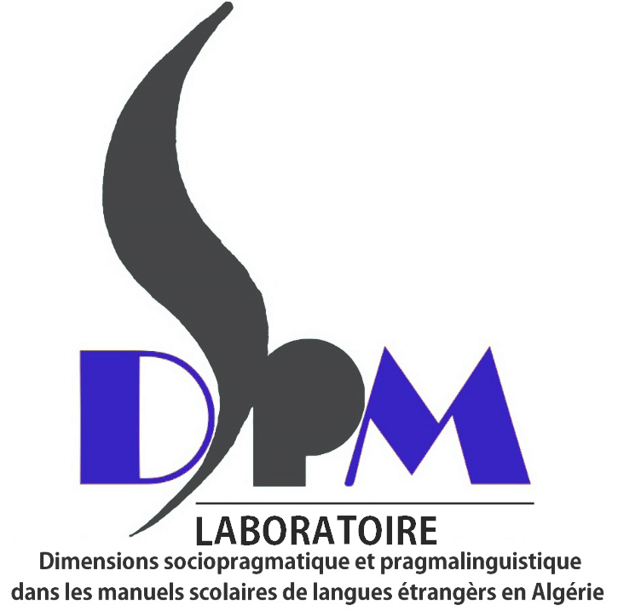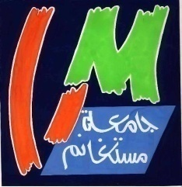

Article Acceptance Certificate

This certificate confirms that the following paper has been accepted for publication in:
The English Lingua Journal, Vol. …(…) 201…

Title
Author(s)
Received
Revised
Accepted

Signed on behalf of the DSPM REASEARCH LAB / Mostaganem University Press

Dr. B.A. Neddar

Editor-in-Chief

